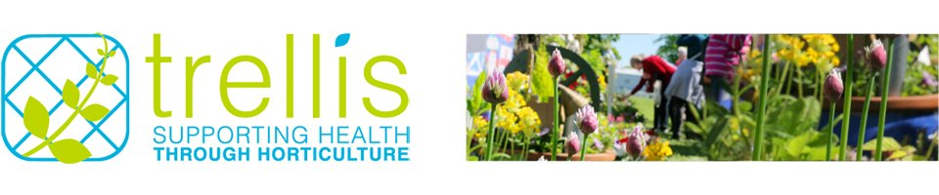
CAREER PROFILE: JENNY FOULKES
Jenny spends her days in the beautiful garden at the Royal Botanic Garden Edinburgh. Jenny is also a freelance fieldworker for Trellis, the National Network for Therapeutic Gardening.

How did you get your job?
I completed a Landscape Management BSc at the University of Reading then built up my experience in both horticulture and working with people to make me a good candidate for relevant jobs. I'm also a fieldworker for therapeutic gardening charity, Trellis.

I've worked in horticulture in the UK and Australia, as a gardener and in nurseries. I've also worked on several community projects, initially managing a project for vulnerable young people at a city farm in Edinburgh.

I left that role to travel to Australia. During that time I worked in horticulture but was keen to keep up my people skills so volunteered at a day care centre for people with additional support needs.

On returning to the UK I got a job with an organisation that aims to help people reduce their environmental impact. I was responsible for community engagement with older people. I also gained lots of other relevant experience; I volunteered for community gardens, completed a permaculture design course and looked after my own garden. My combination of skills and experience matched RBGE’s requirements for their new community project manager, so I managed to combine my project management and horticulture skills with my experiences of working with people.

How relevant was your degree?
My studies were very relevant and have been extremely useful to me. The course included subjects such as botany, practical horticultural skills, human resource management, and sustainability. What I learnt influences the work that I do every day. The university is also well known in the field of horticulture so I think that helped me secure my position too.

What’s a typical working day like?
My current job is very varied. I can find myself writing risk assessments, ordering uniforms, delivering jam-making workshops with community groups, working in the garden with volunteers, meeting visiting VIPs or cleaning out the tool shed. Mostly my role is management based. I have a team of 3 part-time staff and 30+ volunteers. This means that I have less time in the project as that is the role of my staff. I spend most of my time on planning, reporting, budgeting, and people management.

How has your role developed?
The role has grown in scope and responsibility. The project has been very successful so I'm now contracted to do more hours and I have a bigger team to manage. My responsibilities are spreading into other areas at RBGE. I've reached the position that I wanted to get to which is fantastic!
What are your career ambitions?
I want to continue to learn and develop but I'm not sure where that will take me.

What do you enjoy most about your job?
There are lots of great things about my job!

I love the variety, the opportunities (I've travelled to Mexico and the USA as part of my role) and, most importantly, that I am giving people a positive experience of the natural environment. For me, it's all about connecting people from all walks of life to nature and plants. It is very rewarding helping people to learn and have experiences that benefit everyone's health and well-being.

There are many positives to working in this sector. I go to a beautiful garden every day and work with super people. I love that there is a community feel to horticulture and therapeutic gardening.

What are the challenges?
One of the most challenging aspects is that jobs in horticulture are usually part-time. However, the value of enjoying my job outweighs any negatives.

What advice can you give to others hoping for a career in therapeutic gardening (or community gardening)?
I'd recommend gaining experience with a variety of people and communities.

Combine this with some solid horticultural skills. Most project management roles require that you are educated to degree level and, in my opinion, this could be a degree in horticulture or something based around people like occupational therapy.

If you head down the horticulture route, complement this with some volunteering working with people.

If you have a high level of education and experience of working with people, top this up with a good grounding in horticulture with a course like the RHS level 2 certificate in horticulture. Finish this off with some interesting hobbies to make you stand out!

“It is very rewarding helping people to learn and have experiences that benefit everyone's health and well-being”

Jenny’s profile will be published online on the prospects.ac.uk website, February 2017.

For more information about Trellis and the work we do visit:
www.trellisscotland.org.uk

