Joan Wilson, Trellis
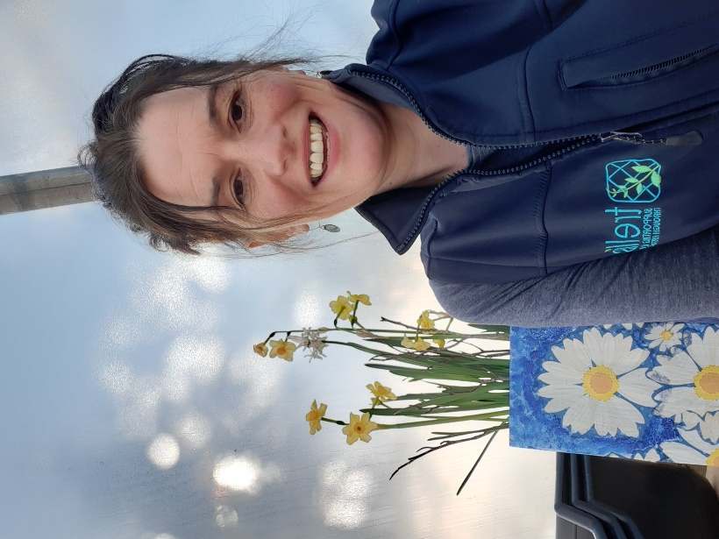
Joan Wilson
HND Garden Design (with Distinction)
RBGE Certificate in Practical Horticulture (with Distinction)

Joan’s youthful days were spent in a farming and hospitality environment, followed by diverse roles in a busy wholesale plant nursery along with employment as a trainer for a Horticultural Recruitment and Training Company.

Since 2014, Joan has worked with Trellis in her current role as Project Advisor. Joan has varied experience of the many therapeutic benefits that garden related and community spirited activity brings and particularly enjoys sharing her own knowledge to support and benefit others.

Joan has personal family experience of the challenges and opportunities that living with a learning and physical disability present, along with experience of managing a Self-Directed Support Budget.

