Alan Gordon
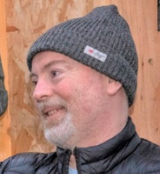
Alan leads on community engagement and project development for Edible Estates as well as supporting the Clovenstone Growers in their neighbourhood garden, helping to deliver children’s Natural Play sessions in partnership with The Green Team locally and helping to deliver community food activities. A varied role that keeps him very busy.

