Dr Amy Baker
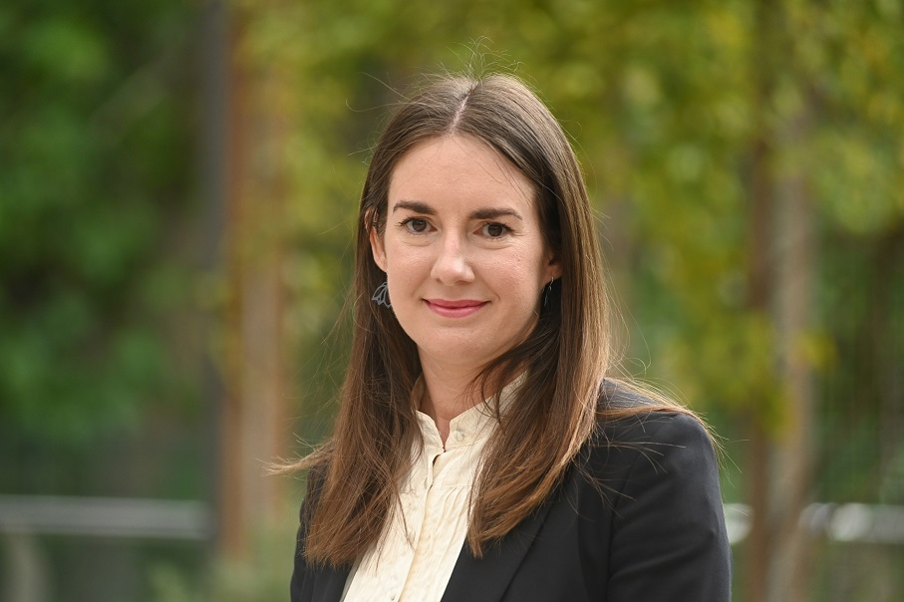
Dr Amy Baker is a researcher and lecturer in the Occupational Therapy Program at the University of South Australia. A key area of Amy’s research focuses on the connection between nature and wellbeing, having supervised or been involved in studies such as horticultural therapy in hospital settings, the meanings of community gardening and a visual analysis of nature play. Amy is a National Committee member of Therapeutic Horticulture Australia and convenes the Research Sub-committee. Amy is also an ANFT certified Nature and Forest Bathing Guide. In her spare time, Amy is an avid gardener and active member of several conservation groups in South Australia.

