Anna María Pálsdóttir
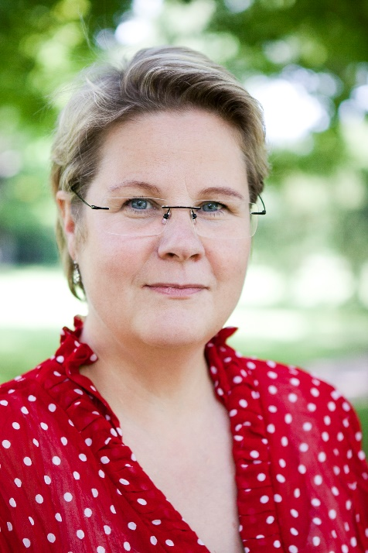
Anna María Pálsdóttir is an Associate professor at the Swedish University of Agricultural Sciences (SLU) in the People and Society department. She is a trained horticulturist and holds a BSc in biology & horticulture sciences as well as MSc and PhD in landscape planning and environmental psychology. She works with conceptual development and scientific evaluations of nature-based and nature-assisted interventions that are conducted in various outdoor environments for different target groups. She also conducts research on the content and design of health-promoting outdoor environments and how we can shape and build sustainable outdoor environments for health and well-being.
Anna María has long experience working in interdisciplinary research teams in environmental psychology, landscape architecture, health and occupational sciences. She is one of the founders of the master program Outdoor Environments for Health and Well-being and in a collaboration with other of educators, built up courses on nature-based and nature and animal assisted interventions as well sensory expression in outdoor environments. Dr. Anna María Pálsdóttir | Externwebben (slu.se)

