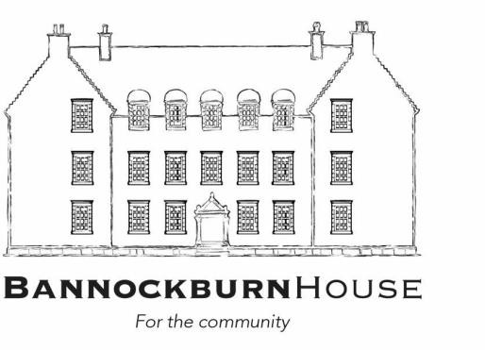

Dear Applicant,

**Bannockburn House – Gardens Volunteer Manager**

# Thank you for your interest in jobs with Bannockburn House Trust. You should note that this contract initially terminates on March 31st, 2023. However, funding dependent, the post may be extended for an additional three years.

The post includes 0.5 Full Time Equivalent posts (17.5hrs pw) with an additional 3.5 hours per week until August 31st.

Please apply by covering letter and CV by e-mail to [admin@bannockburnhouse.scot](mailto:admin@bannockburnhouse.scot) for all other posts, by 5 p.m. on Sunday, 22nd May, 2022.

We hope that you enjoy reading the materials we’ve put together.

Yours,

Jim Bennett

**Chief Executive Officer**

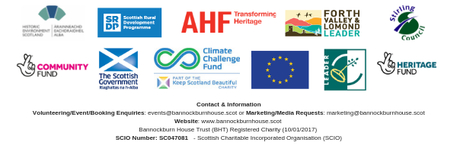



# Bannockburn House Community ownership

The owners of Bannockburn House are the community of Bannockburn. Through their membership of Bannockburn House Trust, local people exercise control over the appointment or removal of Board members and the direction of the Trust, which act on their behalf and be accountable to them through a variety of means including formal AGMs.

# Background

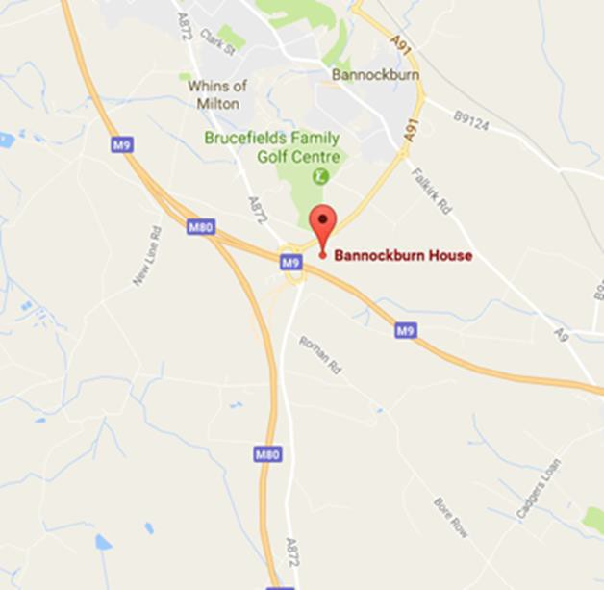The house is located off the A91 close to the Stirling motorway services area (M80 / M9 intersection). It is A listed and around 14,000 sq. feet on four floors surrounded by various outbuildings and chauffeur’s house, set in 30 acres.

# The Bannockburn House Project and Organisation

In 2016, Bannockburn House came on the market and stimulated enormous public interest from the local Bannockburn community. It quickly became evident that the local community wished to carry out a community purchase of the house.

Currently BHT has 11 board members, around 550 members and 200+ signed up volunteers who already maintain the house and gardens, organise events and carry out other project activities.

BHT’s objectives include:

* Ensure Bannockburn House is open and available for the use and enjoyment by local people
* Build a strong community-driven organisation
* Improve and maintain the heritage, building fabric, interiors, fittings / furnishings and grounds of Bannockburn House, in line with community wishes and with regard to the advice of heritage professionals
* Encourage public access (including visitors to the area) to the house and grounds for purposes of leisure, heritage and cultural activities, learning, health and well-being
* Create a visitor attraction that generates income and employment benefitting local people
* Initiate, develop and facilitate a range of community projects and activities, providing benefit to the local community
* Secure all necessary funding and support to protect and conserve the house.

Website: <http://www.bannockburnhouse.scot/>

Facebook: <https://www.facebook.com/BannockburnHouse/>

**The Gardens**

The gardens have been in the process of renewal for around four years.

* At first, this work, carried out by volunteer teams, was about site clearance
* The next stage was organising a water supply
* This moved on to developing our East Field as a horticultural learning space. This space includes three polytunnels, around a dozen raised beds, soft fruit cages and children’s mud kitchen
* We have used the East Field area as a base for climate action training, food growing during the pandemic (1500kgs distributed to vulnerable local people), horticultural training and on-line cookery demonstrations
* Establishing our apiary, maintaining the lawns and creating beautiful surroundings
* Volunteer gardeners, alongside some people on employability programmes, have been the core of all this work
* Latterly, we have developed our enclosed gardens with an accessible path network based on a formal Jacobean style.

The gardens play a central part in our vision for Bannockburn House. Our intention is to further develop them as a hive of volunteer activity, employability training, food production and as a very beautiful place for the public to visit and enjoy.

# Plans for Bannockburn House

The House does not have a collection of artefacts and is not going to be a museum. Its planned use is as a community led heritage visitor attraction. It will provide space and facilities for a range of community led services, projects and activities which could include:

* Newly developed gardens
* Fruit and vegetable production
* Bistro
* apprenticeships / workshops for training
* tours, re-enactments, visitor accommodation
* exhibitions
* Heritage trails
* Events / markets / fayres

**Post: Gardens Volunteer Manager**

**Contract Fixed Term,** up to March 31st 2023

**Salary:** £25k pro rata

**Hours:** 0.5 FTE – 17.5 hours pw.

**Benefits:**

* Workplace pension
* Laptop
* Mobile Phone (or financial contribution to contract)
* Flexible working
* 22 days holidays and 11 public holidays pro rata

**Flexibility:** working hours are flexible and by negotiation, including the use of home working. Attendance each Wednesday at Bannockburn House is expected.

*This post is funded by the Scottish Government through its Investing in Communities Programme*

**Post Overview:**

Volunteers and our Gardens are the heart of Bannockburn House Trust. Therefore, the person undertaking our volunteer support has a key role in providing the support that our garden volunteers and trainees need. Garden Volunteer support will include recruiting, supporting and retaining volunteers/trainees, as well as organising garden work programmes. The role requires tact, diplomacy and the ability to help volunteers from all backgrounds develop themselves personally whilst also delivering the impacts that Bannockburn House Gardens need.

**Key Relationships**

* BHT garden volunteers and Employability trainees
* CEO and Project Support Manager
* Volunteer Support and Events Organisers

**Key Responsibilities**

**Garden Volunteer Coordination Responsibilities**

* Recruiting volunteers and trainees to work on the gardens
* Co-designing with volunteers, a programme of gardening events for their personal development as well as learning programmes
* Supervision and support of volunteers/trainees
* Planning the redevelopment of the gardens
* Managing the physical redevelopment and maintenance of the Gardens
* Working with the CEO and Project Support Manger to order the equipment/resources required, within the prescribed budgets
* Working with the CEO and Project Support Manager and Volunteer Coordinator to develop and ensure the delivery of programmes of learning/training
* Ensure that vegetable, salad/herb, soft fruit and orchard fruit production is enabled and delivered
* Work with the Volunteer Coordinator and Construction volunteer team, to ensure appropriate Health and Safety measures are in place, operational and that all gardens users have inductions
* Liaison with appropriate external agencies
* Compilation of statistics and returns to funders in conjunction with the CEO and Project Support Manager.

# Person specification

* Relevant gardening, vegetable/food production experience
* Previous relevant experience in managing volunteers
* Previous experience in horticultural project management
* An understanding of budget management
* Knowledge / understanding about community led projects and how these relate to delivering positive impacts in the local community
* Preferably good organisation, administration and IT skills
* Good oral and written communication skills
* Excellent team player and motivator
* Possesses knowledge and understanding of compliance issues relating to horticulture
* Proactive self-starter.



