Tanya Bearup
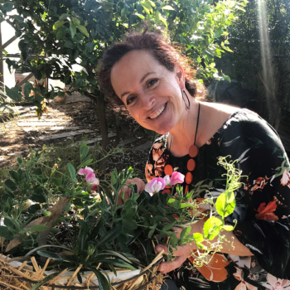
Tanya Bearup is a social worker and horticultural therapist and the founder of “My Garden Space” a social and therapeutic gardening service based in Melbourne, Australia. Tanya 25 years of experience in aged care, disability, youth and family services. Tanya is also a qualified horticulturist and has combined her professions to provide engaging and purposeful evidence based counselling and therapeutic services for individuals and groups utilising gardening and outdoor nature-based activities. Tanya’s passion is gardening and creating nurturing green spaces “with” others and drawing the attention of her fellow gardens to the restorative benefits of nature. Tanya is a member of the Australian Association of Social Workers (AASW) and has been an active member on the national committee of Therapeutic Horticulture Australia (THA) since 2021.

