Anne McAlister, ADA
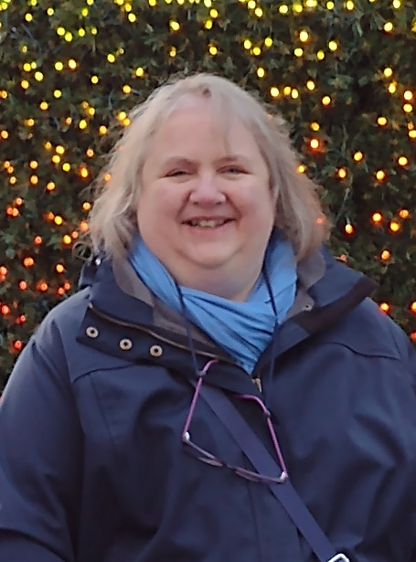
Anne McAlister
I was brought up in Belfast and came to Aberdeen almost 30 years ago when I joined my husband who had been at University here. I worked for a number of years in the public sector and then decided I wanted a complete changed and moved to the third sector and have now been with ADA for 8 years. I was employed to create opportunities for volunteers within the charity and how people with lived experience and others could support clients and staff. One of the first opportunities that came my way was an offer from Aberdeen City Council of the use of a polytunnel as part of a community involvement project. I managed to recruit two keen volunteers and we started a gardening group in 2015.
I am not a gardener myself and usually manage to kill any plants I get, but I do appreciate gardens and love flowers and nature. I am a crafter and love to get involved in making things that relate to gardens and nature. My husband and I enjoy traveling when we can and visiting art galleries were I am a great lover of the paintings of Monet and of his garden at Giverny. I have been lucky enough to visit it and what an amazing garden it is.

