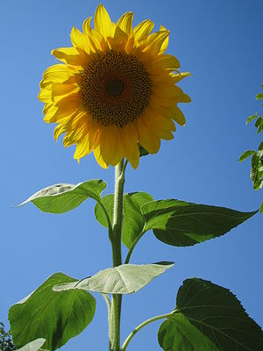
Sunflowers make people smile and birds happy!

In these present, gloomy days Able Community Care is hoping to raise smiles of satisfaction as people of all ages enter our Sunflower Competition and watch their sunflowers grow from a tiny seed to a beautiful flower several feet high.
Our competition to grow the tallest sunflower offers a prize for adults and for children up to sixteen years of age.
The adult prize is a bouquet of flowers, each month for six months either for yourself or for someone you would like to receive them.
For children under sixteen years of age, the prize is a £100 Amazon Voucher
To enter our competition, email to info@ablecommunitycare.com and we will send you your little seed pack with further details.
After receiving this and deciding you would like to enter, email again giving us your name and address which can be as little as: Anne Lincoln. Just so that we can send you updates and notify you if you win. You will not be sent any other material which is not related to this competition.
So, try to see if you can grow the tallest sunflower. August 31st is the last entry date and the winners will be announced in September.
Able Community Care is provider of Live-in Care Services for older people and for people who have a disability. Established in 1980 our services are available in England, Scotland, Wales and the Channel Islands. www.ablecommunitycare.com

